Oshana D.D.

IT24101659

Exercise

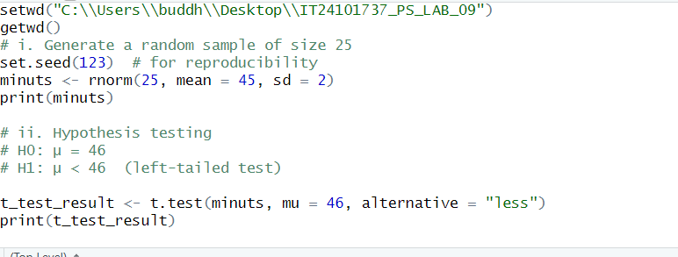

Figure 1.1: R script Question answers

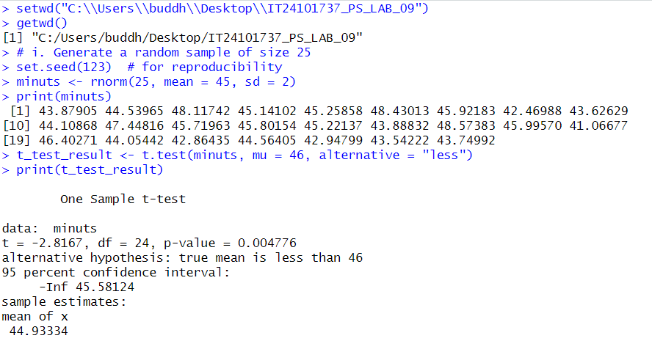

Figure 1.2: console part